TRIANGLE CONGRUENCE
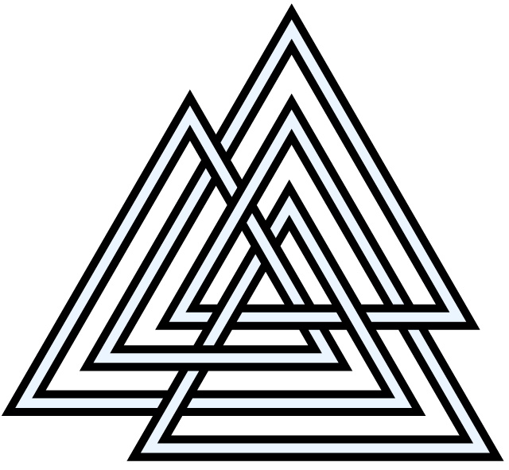

Name:______________________________________ Period:____________
This unit is all about triangles and congruency. You probably already know that triangles are 3-sided closed figures, and you should already know that congruent means ____________ or the same. So, basically this unit is all about PROVING that 2 triangles are or are not exactly the same thing.
Congruence
First, we need to talk about congruence and what it means. Like we said before, if 2 triangles are congruent, then they are ______________ the same on all the parts of both triangles. Triangles are made up of ___________ and ___________, so those not only have to be the same, but also in the SAME ORDER.
Example: Write the congruent sides and angles of the 2 triangles.
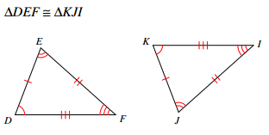

This example was easier because congruent sides and angles were drawn on there for you. Try some of the practice problems on the next couple of pages. Again, if the triangles are written in different orders, then they are WRONG!

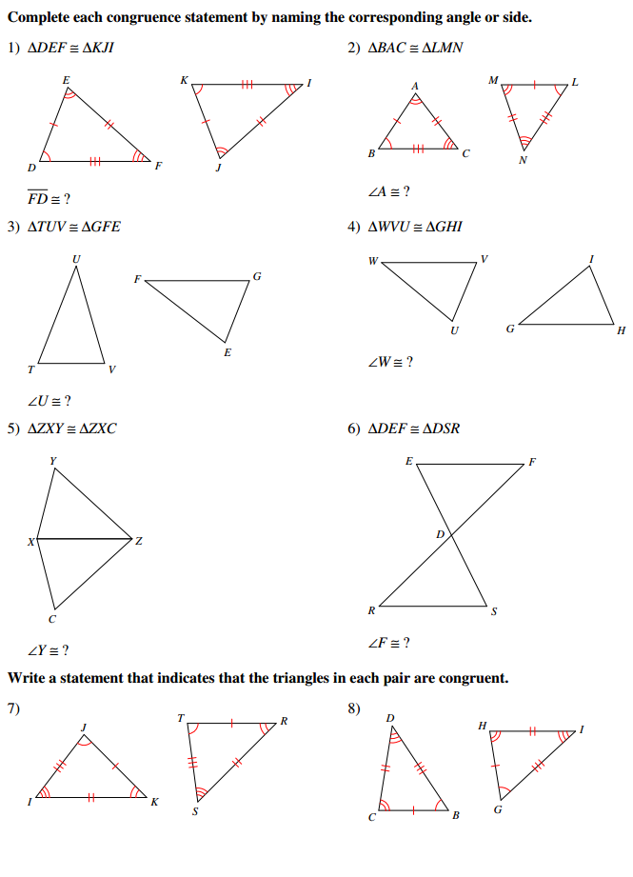
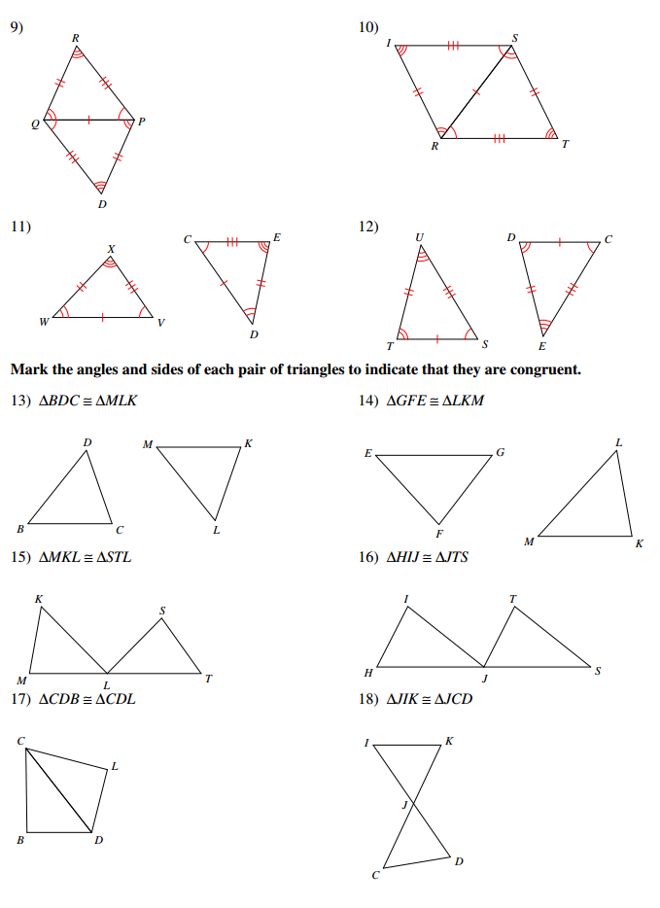
Triangle Congruence Criteria
Now that we know how to work with congruent parts of the triangles, let’s get into how to PROVE that they are the same. Like we said before, triangles are made up of 2 things:________ and ____________. The cool part is, we don’t have to know all of them to know that triangles are or aren’t congruent! We need only ______ parts of any 2 triangles to prove that they are or aren’t congruent, so there are only ______ combinations or ways that we can possibly do it (SSS, SAS, ASA, AAS, AAA, and ASS).
Side-Side-Side (SSS)
Probably the easiest to see is SSS. To show this, all we need is 2 triangles with ______ sides the same. If that is true, then we KNOW for a fact that they are ______________.
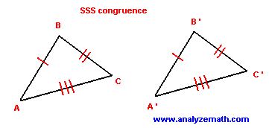
Side-Angle-Side (SAS)
The next type of congruence is SAS. For this type, we need 2 triangles that have congruent _________ with a congruent angle in between. Again, if we have this present, then ALL PARTS of BOTH TRIANGLES are _________________ because of CPCTC.
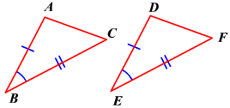
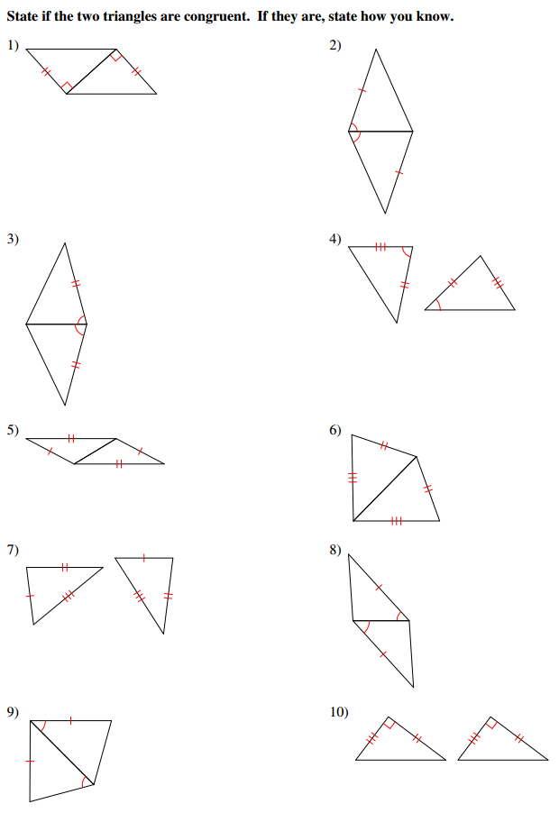
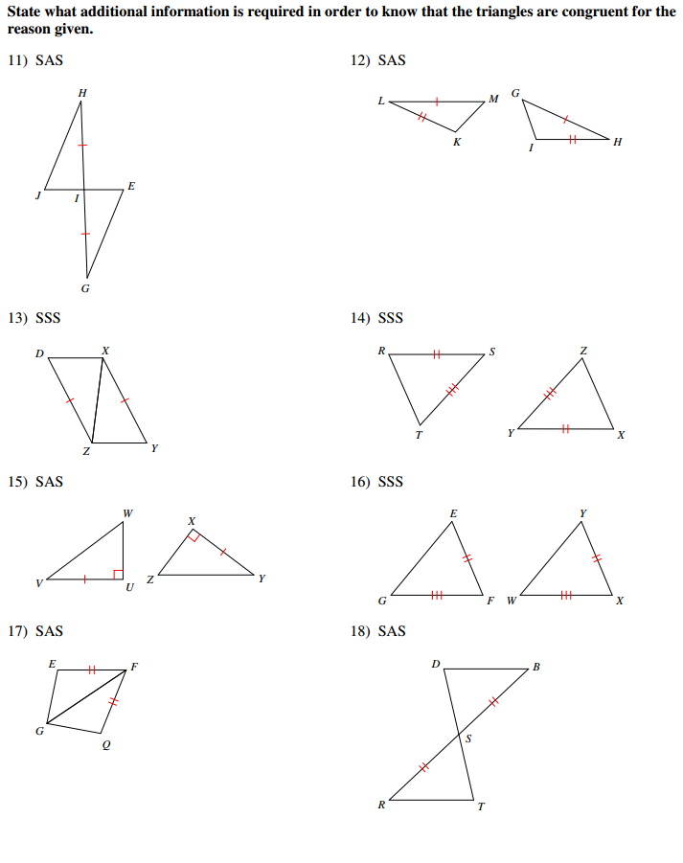

Angle-Side-Angle (ASA)
Another combination of sides and angles that proves triangle congruence is ASA. Again, make sure that you have 2 congruent __________ with a congruent __________ in between them to check. If you do, both triangles are congruent to each other.
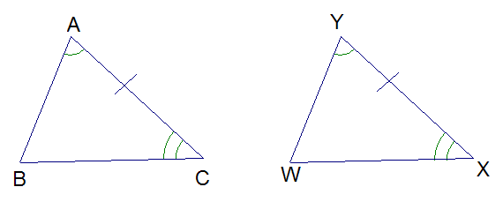
Angle-Angle-Side (AAS / SAA)
The last type of congruence that will work for you every time is AAS. This one can be tricky, though. You have to make sure that when you start at one point on the triangle, you take the ______________ route around it to the last part…otherwise you are not doing it right. For example, in the triangle below we would start at B, then move to C and side AC. On the other triangle, we would start at E, move to C, and finally side DF. A wrong way to do it would be going F-E-DF, because we are skipping side ED and angle D. Basically, if you skip more than 1 part when going around the triangle, you’re gonna have a bad time.
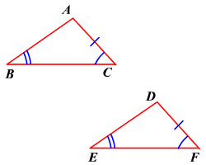
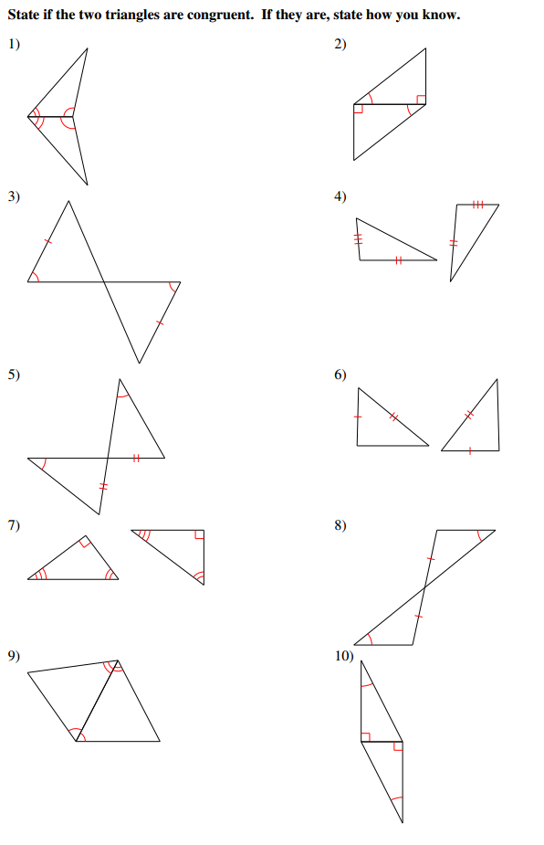
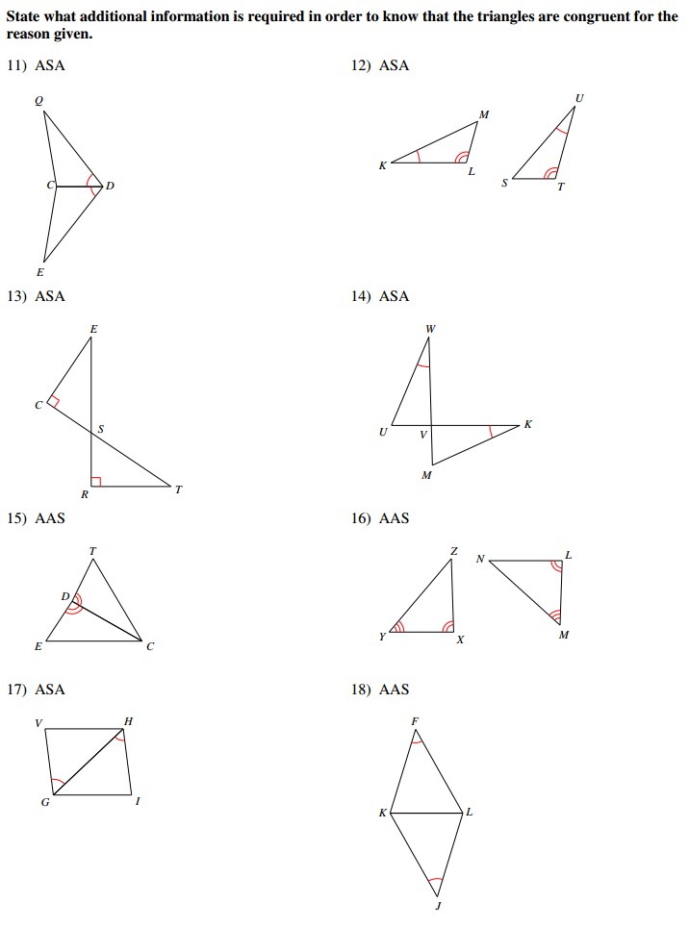
Combinations that DO NOT Work!
Angle-Angle-Angle (AAA)
AAA does NOT work. As you can see in the picture, it is pssible to have 2 triangles with the same angle measures, but DIFFERENT ____________ lengths. Because of this, they can not be used to prove congruence. If you have a hard time remembering this, think of how your math teacher will react if you try to use it (AAAAAHHH!).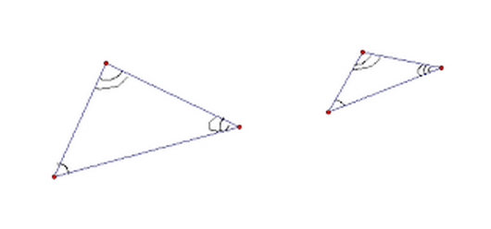

Angle-Side-Side (ASS / SSA)
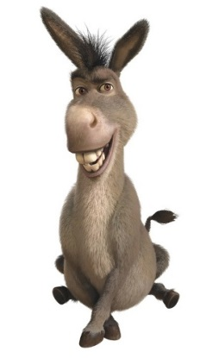
The other type of congruence that doesn’t work is ASS. Again, as you can see in the picture below, you can actually form 2 different triangles with the same combination of ASS. A good way to remember this…if you use it you look like an…
