Geometry
Solid Geometry

Perimeter is the sum of the side lengths of a closed plane figure (2-D shape)
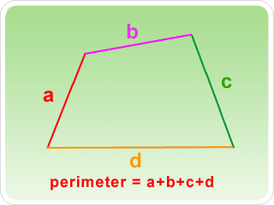
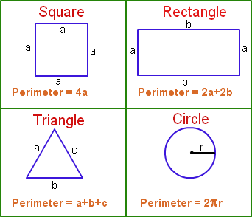

.

Example 1 Finding the Perimeter
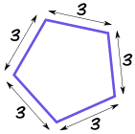
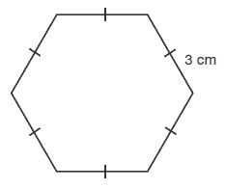
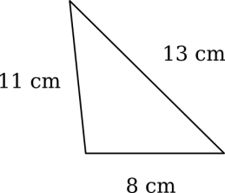
C
B

A

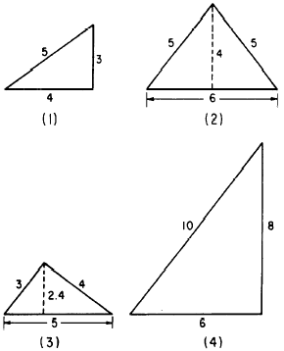

Check Point: Find the Perimeter for each

1

2

3

4

Example 2 Identify the Type of Triangle and Find Its Perimeter and Area
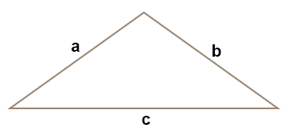
- Given a and b are congruent, a = 4 and c = 7.

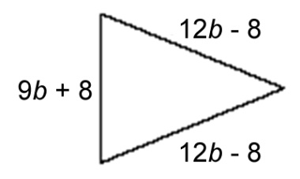

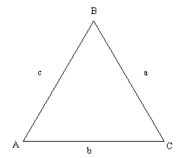

- The meansure angle A = 60º, a$≅$ b $≅$ c and b = 18.

- Given RT ⊥ SP
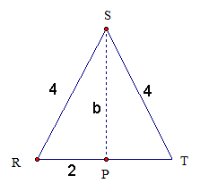
How do you find the value of b?

A net is a diagram of the surfaces of a three-dimensional figure that can be folded to form the three-dimensional figure. To identify a three-dimensional figure from a net, look at the number of faces and the shape of each face.

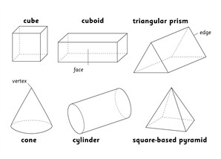

Net of a Cube Net of a Rectangle
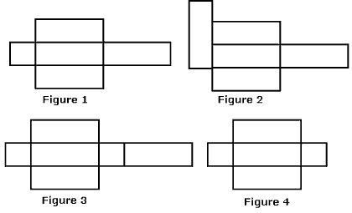
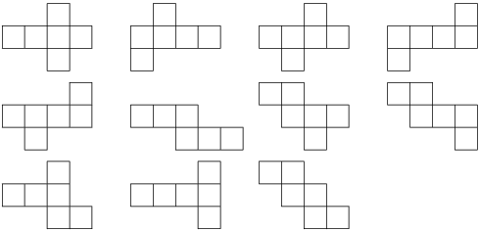

Net of a Cylinder Net of a Pyramid
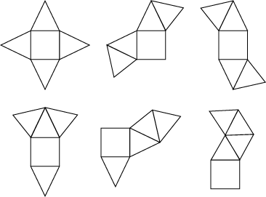
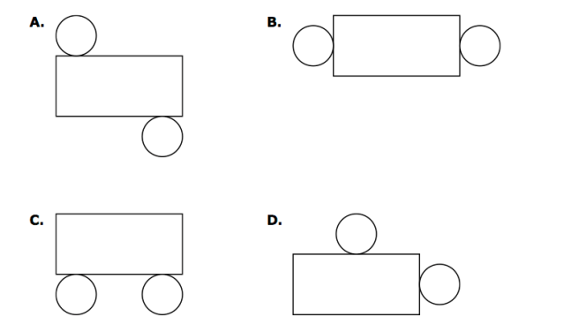

Surface Area of Prisms and Cylinders
Prisms and cylinders have 2 congruent parallel bases. A lateral face is not a base. The edges of the base are called base edges. A lateral edge is not an edge of a base. The lateral faces of a right prism are all rectangles. An oblique prism has at least one nonrectangular lateral face.

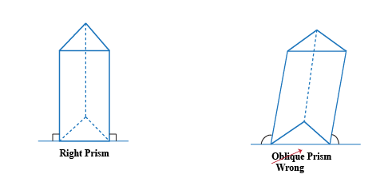
Base edges

Lateral edges
Bases
Bases

Lateral faces

Surface area is the total area of all faces and curved surfaces of a three-dimensional figure.

Example 3 Find the Surface Area and the Volume

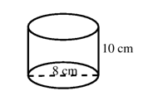
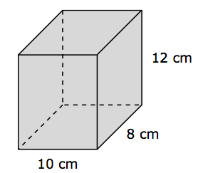
B
A

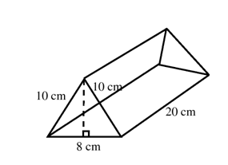

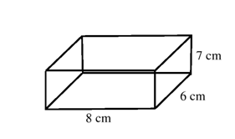
D
C

Solid objects have a degree of compactness of a substance, density. The degree of solidity of the object is measured by the quantity of mass per unit volume.

$denisity= \frac{mass in grams}{volume in cubic centimeter}$ → $d= \frac{m}{v}$

Example 4 Density
- Calculate the density of a material that has a mass of 52.457 g and a volume of 13.5 cm³.

- A student finds a rock on the way to school. In the laboratory he determines that the volume of the rock is 22.7 mL, and the mass in 39.943 g. What is the density of the rock?

- The density of silver is 10.49 g/cm³. If a sample of pure silver has a volume of 12.993 cm³, what is the mass?

