Geometry – Honor
Name: ____________________________________

Circle

What do I know about the circle?
- What is the equation of the circle?

- What is (h, k) in the equation of the circle?

- What is the relationship between the central angle and its arc?

- How do I find arc length?

- What do I know about the inscribed triangle that is formed with the diameter?

- How do I find sector area?

- How do I find the angle inside the circle formed by 2 secant lines?

- How do I find the angle outside the circle formed by 2 secant lines? 2 tangent lines? Or a tangent and secant line?

- What is the relationship of the interior angles of a quadrilateral formed inside the circle?

- Describe the relationship between the tangent line and the radius or the diameter?

- If the radius bisected the chord, what does that mean?

- Is there anything else about the circle that is not mentioned?

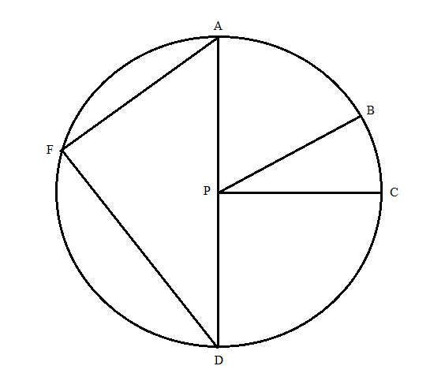
Given: AD = 12 inches, AFD is a semicircle, central angle APB = 55º, measure angle FDA = 36, and APC is a right angle.

Find
- Arc AB = _________
- Arc FA = _______
- Line segment FA = ________
- Line segment FD = _________
- Sector area APB = ___________
- Arc length BC = _________
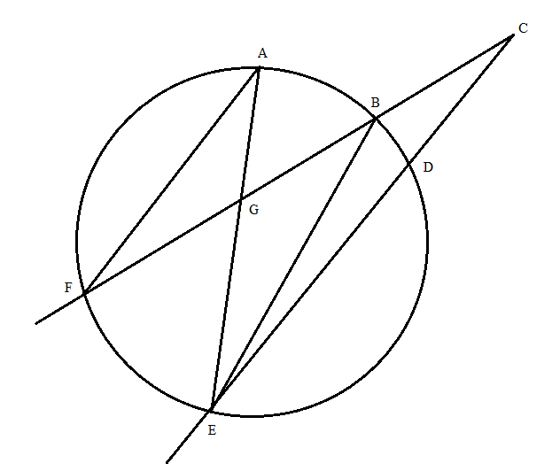
Given: BCD = 27º, BD = 40º, AGB = 55º

Find:
- Arc FE = __________

- FAE = ___________

- EBF = _____________

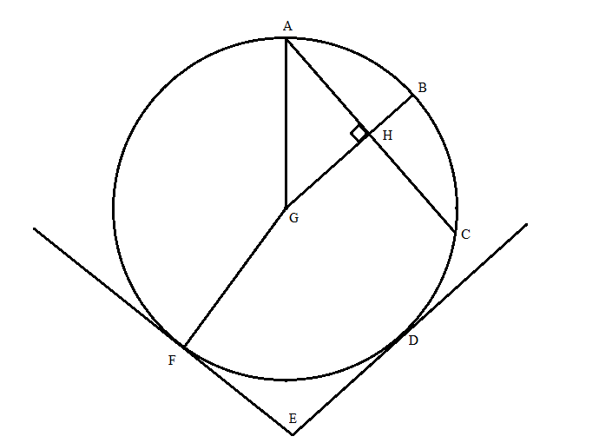
Given: AGF = 120º, radius FG = 5 feet, FED = 85º, FE = 10p – 5 and DE = 9p, HC = 4.

Find:
- Sector area AGF = ___________

- Line segment GH = __________

- Line segment BH = __________

- Arc FD = ___________

- FE = __________

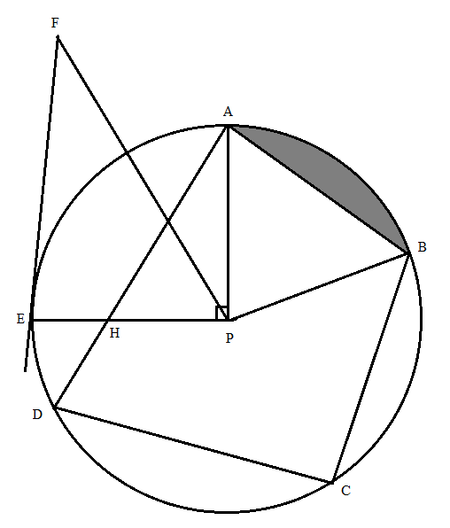
Given: Central angle APB = 70º, radius PB = 15 yards, arc BC = 64, arc DC = 80, PFE = 33º

Find:
- Line segment FE = _________

- Line segment HP = __________

- Shaded area = ____________

- BCD = ________________

Geometry – Honor
Name: ____________________________________

Circle

What do I know about the circle?
- What is the equation of the circle?
(x-h)² + (y-k)² = r²

- What is (h, k) in the equation of the circle?
(h,k) is the center of the circle.

- What is the relationship between the central angle and its arc?
Central angle has the same measurement of its arc.

- How do I find arc length?
Arc length = 2$π$r($\frac{m°}{360}$) unit

- What do I know about the inscribed triangle that is formed with the diameter?
The inscribed angle formed a right triangle with the diameter.

- How do I find sector area?
Sector area = $π$r²($\frac{m°}{360}$) unit square

- How do I find the angle inside the circle formed by 2 secant lines?
The angle measure = $\frac{1}{2}$(the sum of the 2 arcs)

- How do I find the angle outside the circle formed by 2 secant lines? 2 tangent lines? Or a tangent and secant line?
The angle measure = $\frac{1}{2}$(the difference of the 2 arcs)

- What is the relationship of the interior angles of a quadrilateral formed inside the circle?
The opposite angles of the quadrilateral formed inside the circle are supplementary.

- Describe the relationship between the tangent line and the radius or the diameter?
The radius and the tangent line are perpendicular at the point of tangency.

- If the radius bisected the chord, what does that mean?
When the radius bisected the chord, it also formed the right angle.

- Is there anything else about the circle that is not mentioned?
A piece of info is missing for 1 circle, HC = 4.

Given: AD = 12 inches, AFD is a semicircle, central angle APB = 55º, measure angle FDA = 36, and APC is a right angle.

Find
- Arc AB = __55º____
- Arc FA = __72º___
- Line segment FA = __7 in.___
- Line segment FD = ___9.7 in.___
- Sector area APB = ___5.5$π$ in.² or 17.27 in. sq.____
- Arc length BC = ___1.2$π$ or 3.7 in.______
Given: BCD = 27º, BD = 40º, AGB = 55º

Find:
- Arc FE = ___94º____

- FAE = _____47º______

- EBF = ____47º______

Given: AGF = 120º, radius FG = 5 feet, FED = 85º, FE = 10p – 5 and DE = 9p, HC = 4.

Find:
- Sector area AGF = ___8.3$π$ ft² or 26.2 sq ft_____

- Line segment GH = __3______

- Line segment BH = __2______

- Arc FD = ____95º_____

- FE = ___45_____

Given: Central angle APB = 70º, radius PB = 15 yards, arc BC = 64, arc DC = 80, PFE = 33º

Find:
- Line segment FE = ___23.1 yd___

- Line segment HP = ___4.6 yd_____

- Shaded area = ___31.6 yd²______

- BCD = _____108________

