Applications of College Algebra
Chapter 8C – Real Population Growth

Approximate Doubling Time Formula

T_{double} $≈$ $\frac{70}{P}$, where P is the percentage

Example 1 Varying Growth Rate
The average annual growth rate for the world population since 1650 has been about 0.7%. However, the annual rate has been varied significantly. It peaked at about 2.1% during 1960s and is currently (as of 2009) about 1.2%. Find the approximate doubling time for each of these growth rates. Use each to predict world population in 2050, based on a 2009 population of 6.8 billion.

For 0.7%: T_{double} $≈$ $\frac{70}{0.7}$ = 100 years
For 2.1%: T_{double} $≈$ $\frac{70}{2.1}$ = 33 years
For 1.2%: T_{double} $≈$ $\frac{70}{1.2}$ = 58 years.
To predict the world population in 2050, we use the formula

New value = initial value$∙$2^{t/T}_{double}

New value = 6.8 billion $∙$ 2^{41/58} $≈$ 11.1 billion people

If the average annual growth rate between 1950 and 2000 about 1.8%, what is the approximate doubling time? What would the world population be in 2050?

If the current annual growth rate of the United States is 0.7%, what is the approximate doubling time? What would the world population be in 2050?

The world population growth rate is simple the difference between the birth rate and the death rate. For example, suppose that on average there are 8.5 births per 100 people and 6.5 deaths per 100 people per year, and then the population growth rate is
$\frac{8.5}{100}- \frac{6.5}{100}=\frac{2}{100}=0.02=2\%$
So, the overall growth rate
Growth rate = birth rate – death rate
Example 2 Birth and Death Rates
In 1950, the world birth rate was 3.7 births per 100 people and the world death rate was 2.0 deaths per 100 people. By 1975, the birth rate has fallen to 2.8 births per 100 people and the death rate to 1.1 deaths per 100 people. Contrast the growth rates in 1950 and 1975.

In 1950, the growth rate was $\frac{3.7}{100}$ – $\frac{2.0}{100}$ = $\frac{1.7}{100}$ = 1.7%
In 1975, the growth rate was $\frac{2.8}{100}$ – $\frac{1.1}{100}= \frac{1.7}{100}=1.7\%$
Although the birth rates decrease over the 25-years period, the growth rate remained unchanged because the death rates fell equally.

If in 1985, the growth rate was 2.0 per 100 and the death rate was 2.1 per 100 people.
The growth rate will be $\frac{2.0}{100}$ – $\frac{2.1}{100}$ = $-\frac{0.1}{100}$ = - 0.1%
Because the growth rate is negative, the world population declined during this time.

If the birth rates fall more than the death rates, the growth rate of the world population will fall?

Carrying Capacity and Real Growth Model
Carrying capacity is the largest population the environment can support for extended periods of time.
A rapid increase followed by a rapid decrease of a population is known as overshoot and collapse.
A logistic growth is exponential with a fractional growth rate close to the base growth rate r. As the population approaches the carrying capacity, the logistic growth rate approaches zero.

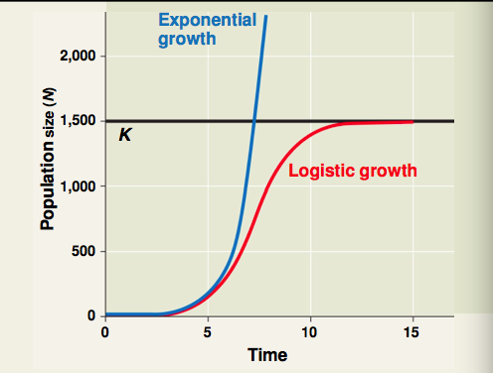

Logistic growth rate = r$∙$(1 - $\frac{population}{carrying capacity}$)

Example 3 Are We Growing Logistically?
Assume that the Earth’s carrying capacity is 12 billion people. Given that the population growth rate peaked in 1960s at about 2.1%, when the population was about 3 billion, it is reasonable to assume that human population has been following a logistic growth pattern since 1960s? Is it reasonable to assume that population has been growing logistically throughout the past century explain.

Need to compare with 2009 growth rate of about 1.2%. Use logistic growth rate formula to solve for r

r = $\frac{growth rate}{(1- \frac{population}{carrying capacity})}$

Then use r to predict growth rate for 2009 population of about 6.8 billion.

Homework: Exercise 8C # 7, 9, 11, 13, 15, 17, 19, 21, 23, 25, 29, 31, 33

