Chapter 6 – C: Normal Distribution

A special and very common type of distribution represented by a bell-shaped curve; it formally called a normal distribution. All normal distributions have the same characteristic bell shape, but they can differ from one another in two ways.
- The location of central peak: Normal distribution is symmetric; the peak represents the mean, median and mode of the data set.
- The variation or the spread of data values around the peak.

Condition for a Normal Distribution
A data set that satisfies the following criteria is likely to have a nearly normal distribution.
- Most data values are clustered near the mean, giving the distribution a well-defined single peak.
- Data values are spread evenly around the mean, making the distribution symmetric.
- Larger deviations from the mean become increasingly rare, producing the tapering tails of the distribution.
- Individual data values results from a combination of man different factors, such as genetic and environmental factors.
Example 1
Which of the following variables would you expect to have a normal or nearly normal distribution?
- Scores on a very easy test.
- Shoe sizes of a random sample of adult women.

Standard Deviation in Normal Distributions
In statistics, the 68–95–99.7 rule is a way to remember the percentage of values that lie within a band around the mean in a normal distribution with a width of one, two and three standard deviations, respectively; more accurately, 68.27%, 95.45% and 99.73% of the values lie within one, two and three standard deviations of the mean, respectively.
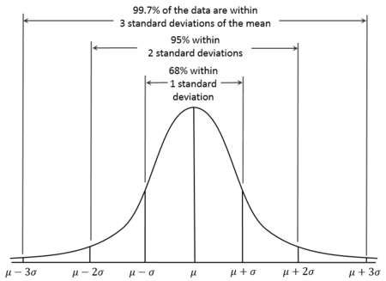
Example 2
` Each test that makes up the SAT is designed so that its scores are normally distributed with a mean of 500 and a standard deviation of 100. Interpret this statement according to the 68-95-999.7 rule.

Example 3
A survey finds that the prices paid for 2-years-old Ford Fusion cars are normally distributed with a mean of $10,500 and a standard deviation of $500. Consider a sample of 10,000 people who bought 2-years-old Ford Fusions.
- How many people paid between $10,000 and $11,000?
- How many people paid less than $10,000?
- How many people paid more than $12,000?

Standard Scores
The 68–95–99.7 rule applies to data values that are exactly 1, 2 or 3 standard deviations from the mean. The number of standard deviations a data value lies above or below the mean is call its standard score (or z-score), which is often abbreviated by the letter z.
The standard score of the mean is z = 0, because it is 0 standard deviations from the mean.
The standard score of a data values 1.5 standard deviations above the mean is z = 1.5.
The standard score of a data value 2.4 standard deviations below the mean is z = -2.4.

$$z=standard score= \frac{data value-mean}{standard deviation}$$
Example 4
Stanford-Binet IQ test is designed so that scores are normally distributed with a mean of 100 and a standard deviation of 16. Find the standard scores for IQ scores of 95 and 125.

Standard Scores and Percentile
The nth percentile of a data set is the smallest value in the set with the property that n% of the data values are less than or equal to it. A data value lies between two percentiles is said to lie in the lower percentile.
Table

Example 5
Cholesterol levels in men 18024 years of age are normally distributed with a mean of 178 and a standard deviation of 41.
- In that percentile is a man with a cholesterol level of 190?
- What cholesterol level corresponds to the 90th percentile, the level at which treatment may be necessary?

Example 6
The height of American women aged 18-24 are normally distributed with a mean of 65 inches and a standard deviation of 2.5 inches. In order to serve in the U.S Army, women must be between 58 and 80 inches tall. What percentage o women are ineligible to serve based on their height?

Homework: Quick Quiz 1-10
Does It Make Sense? 5-6
Basic Skills & Concepts: 19, 21, 23, 25, 27, 29

