Key terms: Gross income, adjustments, adjusted gross income, taxable income, total tax, tax refund, exemptions, deductions, filing status, standard deduction, itemized deductions, progressive income tax, marginal tax rates, mortgage interest tax deduction, capital gains (short-term and long term), and tax deferred savings.
Gross income – All income of your for the year.
Adjustments – untaxed portions of gross income.
Adjusted gross income (AGI)– Gross income subtracted/less/minus adjustments.
Exemptions and Deduction – Amounts that you subtract from your adjusted gross income before calculating your taxes.
Taxable income – Amount after you subtracted exemptions and deductions.
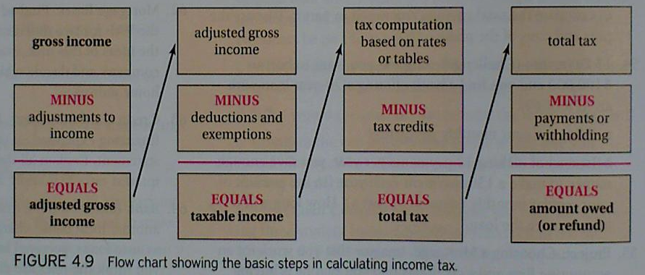
Example 1
Karen earned wages $34,200, received $750 in interest from saving account, and contributed $1200 to tax-deferred retirement plan. She was entitled to a personal exemption of $3650 and to deductions totaling $5900. Find her gross income, adjusted gross income (AGI), and taxable income.
Gross income = $34,200 + $750 = $34,950

Karen’s $1,200 contribution to tax-deferred retirement plan counts as adjustment to her gross income.
AGI = gross income – adjustments = $34,950 - $1,200 = $33,750

Karen’s taxable income
Taxable income = AGI – exemptions – deduction
= $33,750 - $3650 - $5,900 = $24,200

Example 2
John earned wages of $43,500, received $1,500 in interest from a saving account, and contributed $2,500 to a tax-deferred retirement plan. He was entitled to a person exemption of $3,500 and had deductions totaling $4,150. What is his gross income, adjusted gross income, and taxable income?

Example 3
Stephanie earned wages of $38,000, received $150 of interest from a saving account, and was entitled to a person exemption of $3,500 and a standard deduction of $4,150. What is Stephanie gross income, adjusted gross income and taxable income?

Example 4 – Work this problem on a separated sheet of paper.
Max earned wages of $98,750, received $5,000 of interest from a saving account, and contributed $7,000 to a tax-deferred retirement plan. He was entitled to a person exemption of $4,300 and had deductions totaling of $10,050. What is Max gross income, adjusted gross income and taxable income?
Filing status – Single or married. There are four different categories.
Single – unmarried, divorced, or legally separated
Married filing jointly – you and your spouse file a single tax return.
Married filing separately – you and your spouse file 2 separated tax returns.
Head of house hold – applies if you are unmarried and are paying more than half of the cost of supporting a dependent child or parent.
Standard deductions – The amount of which depends on your filing status (fixed amount).
Itemized deductions – You add up all the individual deductions to which you are entitled.

Example 5
Suppose you have the following deductible expenditures: $2500 for interest on a home mortgage, $900 for contributions to charity, and $250 for state income taxes. Your filing status entitles you to a standard deduction of $5700. Should you itemize your deductions or claim standard deduction?

Total deductible expenditures is $2500 + $900 + $250 = $3630

Example 6
Your deductible expenditures are $7,600 for interest on a home mortgage, $3750 for contributions to charity, and $550 for state income taxes. Your filing status entitles you to a standard deduction of $10,500. Should you use itemize deduction or standard deduction?

Example 7 – Work this problem on the same sheet of paper for Example 4.
Your deductible expenditures are $2,700 for contributions to charity, and $450 for state taxes. Your filing status entitled you to a standard deduction of $4,750. Should you use itemize deduction or standard deduction?

Marginal tax rates – Tax rates vary depend on income bracket.
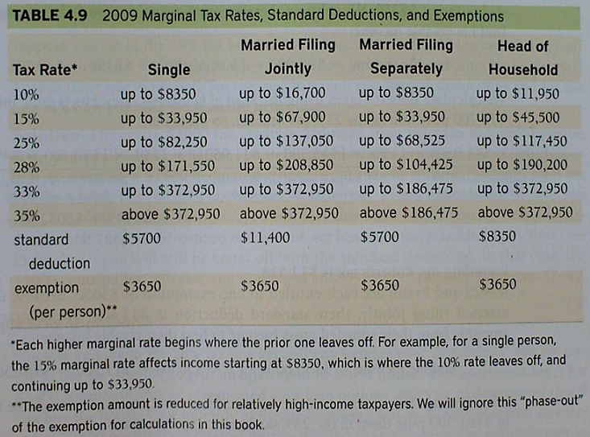
Total tax – Amount you owe to the IRS.
Tax refund – Amount you will get back from the IRS.

Example 8
Use 2009 Marginal Tax Rates, Standard Deductions and Exemptions to calculate the tax owed for each individual. Assume that they all claim the standard deduction and neglect any tax credits.

a – Deirdra is single with no dependent. Her adjusted gross income is $90,000.
- Find Deidra taxable income. She is entitled to a person exemption of $3650 and a standard deduction of $5700.
Taxable income = AGI – exemption – deductions
= $90,000 - $3650 - $5700 = $80,650
- Find Deirdra tax rate. She is in 25% tax bracket because her income is above $33,950 and below $82,250. Deirdra has to pay 10% on the first $8350, 15% on her taxable income above $8350, but below $33,950, and 25% on her taxable income above $33,950.
(10% x $8350) + (15% x [$33,950 - $8350]) + (25% x [$80,650 - $33,950])
$835 + $3840 + $11,675 = $16,350 total tax
b – Robert is a head of household taking care of two dependent children. His adjusted gross income is also $90,000.
- Robert is entitled to 3 exemptions of $3650 each – one for him, one for each of his two children. As a head of household, he is also entitled to a standard deduction of $8350.
Taxable income =

- Find Robert tax rate.

c – Jessica and Frank are married with no dependent. They file jointly. They each have $90,000 in adjusted gross income, making a combined of $180,000. Find Jessica and Frank total tax.

Homework Due on Wednesday 9/8/2015
SHOW YOU R WORK
#19, 21, 23, 24, 25, 27, 29, 31

