Principal – The original amount.
Installment loan – A loan that you pay off with equal regular payments.
Loan payment formula
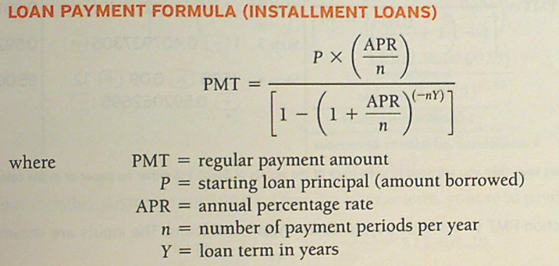
Mortgage – Installment loan designed specifically to finance a home.
Down payment – The amount of money you must pay up front in order to be given a mortgage or other loan.
Closing costs – Fees you must pay in order to be given the loan.
Points – Fees charged as points, each point is 1% of the loan amount.
Fixed rate mortgage – The simplest type of home loan, which guaranteed that the interest rate will not change over the life of the loan (15-30 years term).
Adjustable rate mortgage (ARM) – The interest rate of the loan changes whenever the prevailing rates change. ARMs generally have much lower initial interest rates, but only for a short period of time.
****NO PREPAYMENT PENALTY****

Example 1 – Student Loan
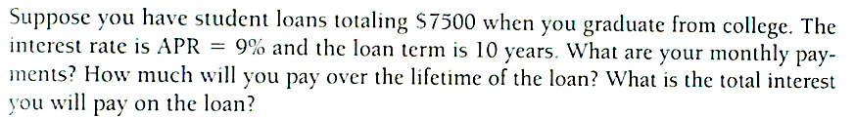

- Write down what we know.
PMT = __________
P = _________
APR = ___________
n = _________
Y = ___________
- Replace/Substitute the variables with numerical values.
- Use calculator to compute the missing information.
***PEMDAS***

Example 2 – Principal and Interest Payments

Example 3 – Choice of Auto Loans
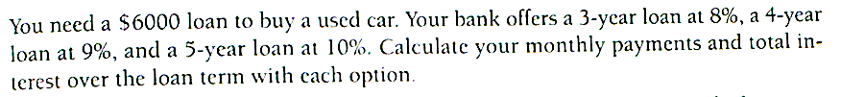

- Write down what we know.
PMT = __________
P = _________
APR = ___________
n = _________
Y = ___________
- Replace/Substitute the variables with numerical values.
- Use calculator to compute the missing information.
***PEMDAS**

Example 4 – For the loan in Example 3, calculate the portions of your payments that go to principal and to interest during the first 2 years.

Example 4 – A Deeping Hole.
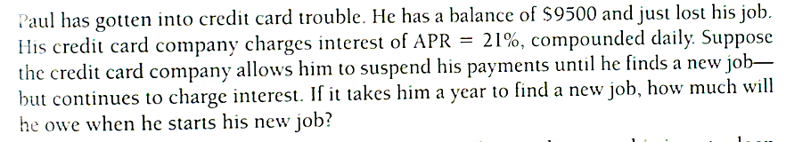

Example 6 – Fixed Rate Payment Options
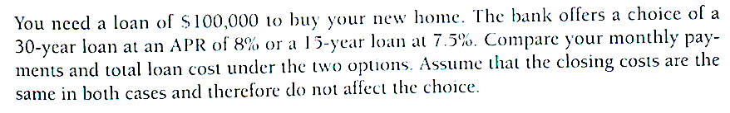

Homework due on Monday 8/24/2015

For the following problems
- Identify the loan principal, the annual interest rate, the number of payment per year, the loan term, and the payment amount.
- How many total payments does the loan require? What is the total amount paid over the full term of the loan?
- Of the total amount, what percent is paid toward the principal and what percent is pay for the interest.

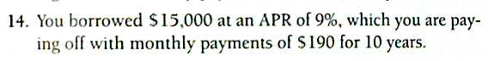

For the following problems
- Calculate the monthly payment.
- Determine the total amount paid over the term of the load.
- Of the total amount, what percent is paid toward the principal and what percent is pay for the interest.

15. A student loan of $50, 000 at a fixed APR of 10% for 20 years.

17. A home mortgage of $200,000 with a fixed APR of 7.5 for 30 years.

21. You borrow $10,000 over a period of 3 years at a fixed APR of 12 %.

23. You borrow $150,000 over a period of 15 years at a fixed APR of 8%.

