The important of Taking Control of Your Finances
Manage personal spending under control
Keep track of your __________ and _____________________.

Keys Terms: Cash flow, budget, bank balance, debit, credit, and impulse purchase
- Cash flow - the total amount of money being transferred into and out of a business, especially as affecting liquidity. The amount of money you earn and how much you spend that effect you’re the amount of money you can save.
- Budget - an estimate of income and expenditure (expense) for a set period of time.
- Bank balance - the amount of money held in a bank account at a given moment.
- Debit - an entry recording an amount owed, listed on the left-hand side or column of an account. Remove money from your account.
- Credit - an entry recording a sum received, listed on the right-hand side or column of an account. Add money to your account.
- Impulse purchase - an unplanned decision to buy a product or service, made just before a purchase. One who tends to make such purchases is referred to as an impulse purchaser or impulse buyer.

Cash flow = Income – Expenses/spending
Monthly cash flow = monthly income – monthly expenses/spending
Yearly cash flow = yearly income – yearly expenses/spending.

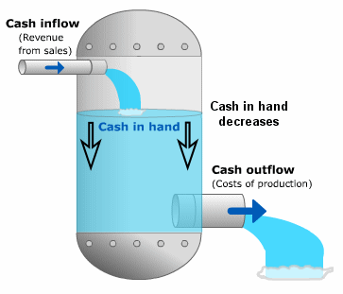
Example 1. College Student Budget
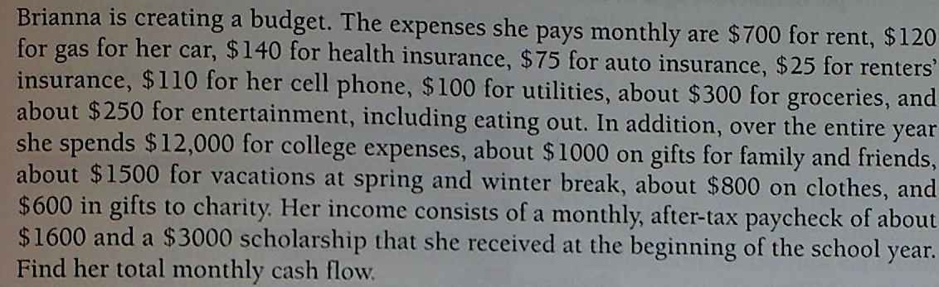

__________cash flow = Monthly __________ – monthly ___________________
Monthly cash flow = Total Monthly Income – Total Monthly Expenses
Income = $1600 per month from work and $3000 yearly scholarship
Total monthly income = $_____+ $3000/__ = $1600 + $250 = $_______
Other yearly expenses
(College, gifts, vacation, cloth, charity) = ($12,000+$1000+$1500+$800+$600) = $15,900
Monthly expenses
Rent = $_____
Gas = $_____
Health Ins. = $_____
Auto Ins. = $______
Rental Ins. = $______
Phone bill = $________
Groceries = $______
Other expenses = $15,900/___ = $1325
Total monthly expenses = $_______
Monthly cash flow = $______ - $________ = __________

Example 2. Latte Money
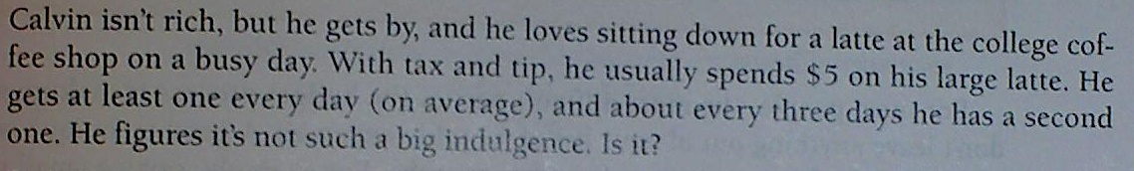

Drink One a day =>_____ in a year = ______lattes
A second latte every 3 day = 365/__ = 122 more (rounding up)
In total 365 + 122 = ______ lattes
Cost for a latte: $_____
_____ x $___ = $________a year on lattes

Practice: Work individually, pair or group of 4
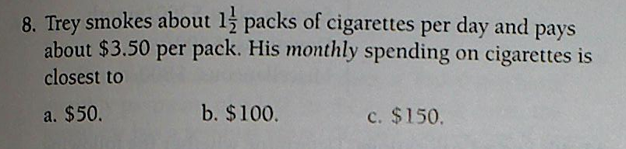

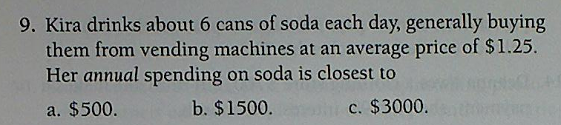

Example 3. Cost of Car
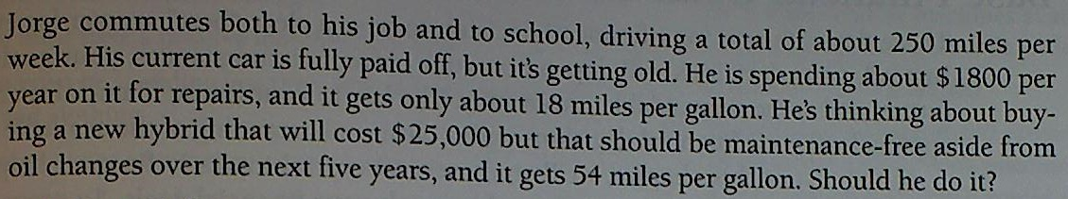

He drives _____ miles/week
For a year, 250 x ____weeks = _______ miles
Current car, _____miles/gallon of gas
13,000/18 = ____gallon per year
Assume gas costs $3/gal, 720 x $3 = $______for gas
Hybrid _____miles/gallon of gas
13,000/54 = app. ______gallon per year
____x $____ = $720 for gas
Jorge will save $1440: $________ - $ ________ = $1440
He also saves $________ on yearly repair. Total saving = $_______ + $________= $3240.
For the next 5 yrs, total saving on gas and repair is $3240 x 5 = $_________
The cost of new hybrid car with maintenance free is $25,000.
Does it worth getting a new car? Depend on your reason.

Example 4. Credit Card Interest
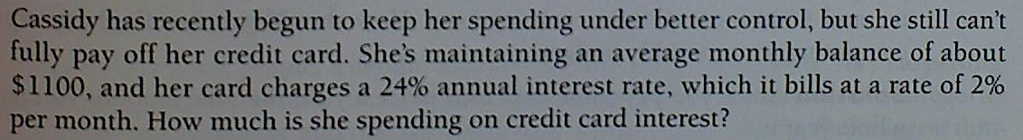

Annual percent interest rate: ____%
Average monthly rate: 24/____ = ____%
At 2% monthly interest with $______ balance
Monthly interest accrual: $______x______ = $22
Yearly interest accrual: $22x12 months = $264

Homework due next class. Wednesday 8/12/2015

