Applications of College Algebra
Chapter 2.4 – Set Operations and Venn Diagrams with Three Sets

Set Operations with Three Sets
Given U = {1, 2, 3, 4, 5, 6, 7, 8, 9}
A = {1, 2, 3, 4, 5}
B = {1, 2, 3, 4, 6}
C = {2, 3, 4, 6, 7}

Find each of the following sets:
- A ∩ (B ∪ C)
- (A ∪ B) ∩ (A ∪ C)
- A ∪ (B ∩ C)

Given U = {a, b, c, d, e, f}
A = {a, b, c, d}
B = {a, b, d, f}
C = {b, c, f}

Find each of the following sets:
- A ∩ (B ∪ C)
- (A ∪ B) ∩ (A ∪ C)
- A ∪ (B ∩ C)

Determining Sets from a Venn Diagrams with Three Intersecting Sets
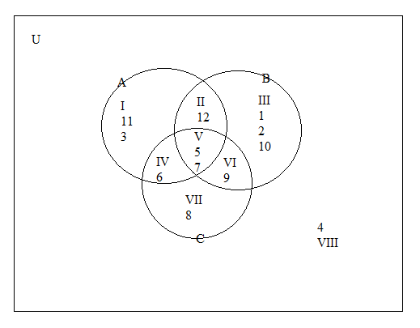
- A =
- A ∪ B =
- B ∩ C =
- Cʹ
- A ∩ B ∩ C

Proving the Equality of Sets
Regardless of which set we choose for A and B in universal set U,
(A ∩ B)ʹ = Aʹ ∪ Bʹ

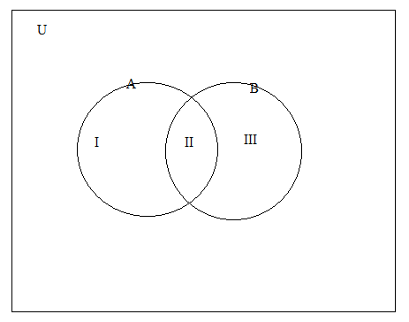

Homework: Exercise 2.4 # 1-77 odd

