Applications of College Algebra
Chapter 2.3 – Venn Diagrams and Set Operations

Universal Sets and Venn Diagrams
The general set is called the universal set. A universal set, symbolized by U, is a set that contains all the elements being considered in a given discussion or problem.

The set of students who speak English at home.
The set of students who speak Navajo at home.
The set of students who speak English and Navajo at home.
The set of students who speak neither English nor Navajo at home.

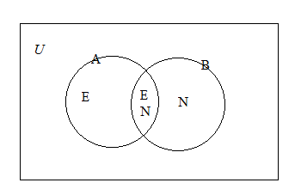
U = the set of students

Example 1 Determining Sets from a Venn Diagrams
Use the Venn diagram to determine each of the following sets:
- U
- A
- The set of all elements in U that are not in A.
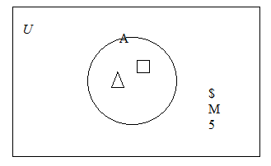

Use the Venn diagram to determine each of the following sets:
- U
- A
- The set of all elements in U that are not in A.
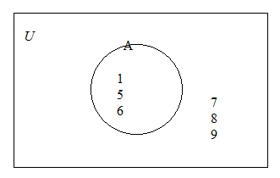

Representing Two Sets in a Venn Diagrams
Disjoint Sets – Two sets that have elements in common.
Proper Subsets
Equal Sets – The same set.
Sets with Some Common Elements – There exist at least 1 common element.
Example 2 Determining Sets from a Venn Diagrams
Use the Venn Diagrams to determine each of the following sets:
- U
- B
- The set of elements in A but not in B
- The set of elements in U that are not in B
- The set of elements in both A and B
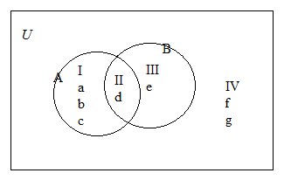

Use the above Venn Diagrams to determine each of the following sets:
- A
- The set of elements in B but not in A
- The set of elements in U but not in A
- The set of elements in U but not in A or B.

The Complement of a Set
The complement of set A, symbolized by Aʹ, is the set of all elements in the universal set that are not in A.
Aʹ = {x| x ∈ U and x ∉ A}

Let U = {1,2,3,4,5,6,7,8,9} and A = {1,3,4,7}. Find Aʹ.
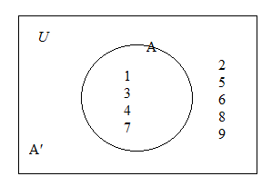

The Intersection of Sets
The intersection of sets A and B, written A ∩ B, is the set of elements common to both set A and set B.
A ∩ B = {x| x ∈ A and x ∈ B}

Example 3 Finding the Intersection of Two Sets
Find each of the following intersections:
- {7,8,9,10,11} ∩ {6,8,10,12}
- {1,3,5,7,9} ∩ {2,4,6,8}
- {1,3,5,7,9} ∩ ∅
- {a, b, c, d, e, f} ∩ {b, e}

The Union of Sets
The union of sets A and B, written A ∪ B, is the set of elements that are members of set A or of set B or of both sets.
A ∪ B = {x| x ∈ A or x ∈ B}

Example 4 Finding the Union of Two Sets
Find each of the following unions:
- {7,8,9,10,11} ∪ {6,8,10,12}
- {1,3,5,7,9} ∪ {2,4,6,8}
- {1,3,5,7,9} ∪ ∅

The Empty Set in Intersection and Union
For any set A
- A ∩ ∅ = ∅
- A ∪ ∅ = A

Example 5 Performing Set Operations
Given
U = {1, 2, 3, 4, 5, 6, 7, 8, 9, 10}
A = {1, 3, 7, 9}
B = {3, 7, 8, 10}

Find each of the following sets:
- (A∪ B)ʹ
- Aʹ ∩ Bʹ

Given
U = {a, b, c, d, e}
A = {b, c}
B = {b, c, e}

Find each of the following sets:
- (A ∪ B)ʹ
- Aʹ ∩ Bʹ

The Cardinal Number of the Union of Two Finite Sets
n(A ∪ B) = n(A) + n(B) – n(A ∩ B)

Homework #1-108: 2 problems per section.

