Applications of College Algebra
Chapter 10 – Geometry
10.4 – Area and Circumference
15.5 – Volume

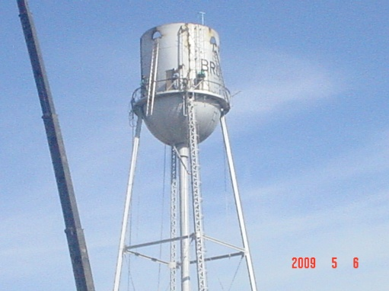

Lets say the above water tower formed by a semicircle with the radius r = 10 feet and a cylinder with the height h = 20 feet. How much water is this water tower when it is full?

Circumference –

Area –

Triangle –

Square –

Rectangular –

Trapezoid –

Parallelogram –

Circle –

Example 1 – A plastering contractor charges $18 per square yard. What is the cost of plastering 60 feet of wall in a house with a 9-foot ceiling?

Example 2 – A circular rug is 6 feet in diameter. How many feet of fringe is required to edge this rug?

Example 3 – A machine produces open boxes using square sheets of metal measuring 12 inches on each side. The machine cuts equal-sized squares who sides from each corner. Then it shapes the metal into an open box by turning up the sides. Find the volume of the box.

Example 4 – Although the Eiffel Tower in Paris is not a solid pyramid, its shape is approximates that of a pyramid with a square base measuring 120 feet on a side and a height of 980 feet. If it were a solid pyramid, what would be the Eiffel Tower’s volume, in cubic yards?

Volume –

Square –

Rectangle –

Sphere –

Pyramid –

Cylinder –

Example 5 – The tunnel under the English Channel that connects England and France is the world’s longest tunnel. There are actually three separate tunnels built side by side. Each is a half-cylinder that is 50,000 meters long and 4 meters high. How many cubic meters of dirt had to be remove to build the tunnel?

Homework 10.4 p564 # 5-17, 21- 31, 37, 39, 45, 41, 49, 51 odd
Homework 10.5 p573 # 1-19, 25-29, 39, 41, 43, 47

