Applications of College Algebra
Chapter 10 – Geometry
10.3 – Polygons, Perimeter, and Tessellations

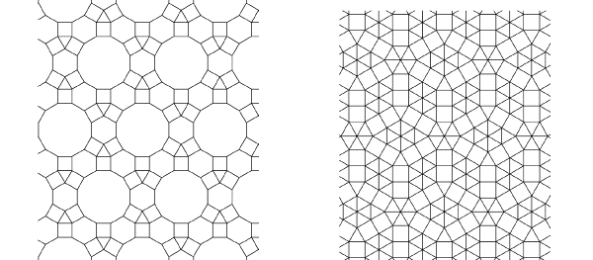

Can a tessellation be created using only regular ten-sided polygons?

No, because the sum of measure angles at each vertex does not equal to 360º

What is tessellation? (Tiling) A relationship between geometry and the visual art is found in art form.

What is polygon? Any closed shaped in the plane formed by three or more line segments that intersect only at their endpoints.

What is a regular polygon? A polygon whose sides are all the same length and whose angles all have the same measure.

The angles of a polygon – (n-2)180 = total degree of the measure angles.

Perimeter – Total distance around the object.

- A rectangular field is five times as long as it is wide. If the perimeter of the field is 288 yards, what are the field’s dimensions?

- A basketball court is a rectangle with a perimeter of 86 meters. The length is 13 meters more than the width. Find the width and length of the basketball court.

- A rectangular field is 70 feet long and 30 feet wide. If fencing costs $8.00 per yard, how much will it cost to enclose the field?

Homework 10.3 p555 #21, 23, 31, 32, 37, 39, 41, 43, 47, 49

