Applications of College Algebra
Chapter 10 – Geometry
10.1 – Points, Lines, Planes, and Angles

Math tells us three of the saddest love stories
- Tangent lines who had one chance to meet and then parted forever.
- Parallel lines who were never meant to meet.
- Asymptotes who can get closer and closer but will never be together.
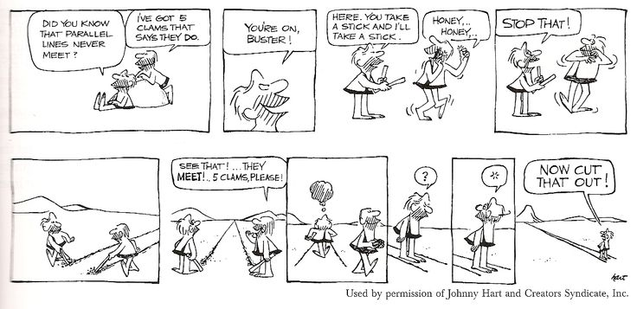

- Use the definite of parallel lines to explain the joke in the above cartoon.

- The picture shows a window with parallel framing in which snow has collected in the corners. What property of parallel lines is illustrated by where the snow has collected?

- The picture shows the top of an umbrella in which all the angles formed by the spokes have the same measure. Find the measure of each angle.

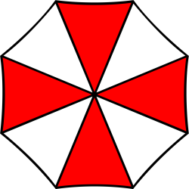

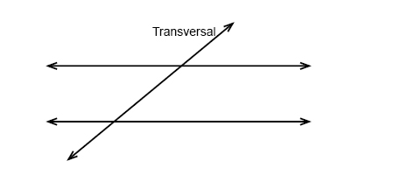
k

m

n

Lines m and n are _parallel___.

Line k is a transversal – A line intersects a pair of parallel lines.

Consecutive angle – Two interior angles lying on the same side of the transversal cutting across two parallel lines.

Alternate interior angle – Interior angles that do not have a common vertex on alternate sides of the transversal.

Alternate exterior angle – Exterior angles that do not have a common vertex on alternate sides of the transversal.

Vertical angle – opposite angles formed by 2 intersecting lines.

Corresponding angle – One interior angle and 1 exterior angle on the same side of the transversal.

Perpendicular line – Two intersecting lines formed 90º angle.

Ex. 1: Find the value of x.
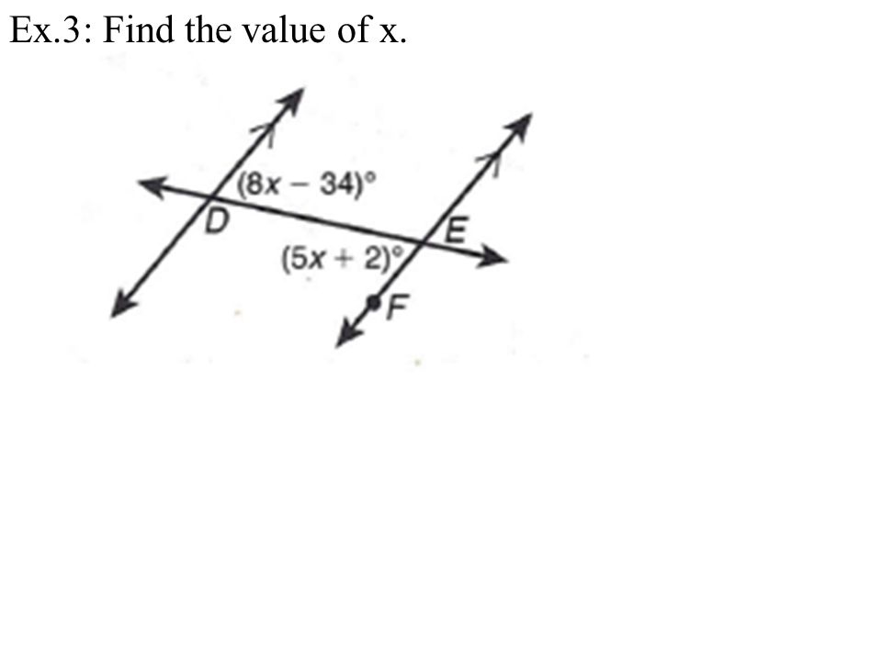

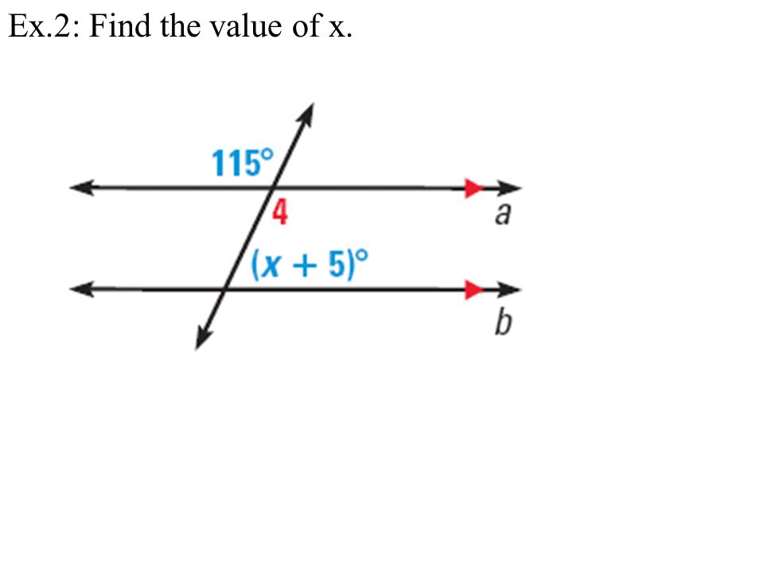
Ex. 2: Find the value of x.

Homework 10.1 p 537 #1-13, 25-27, 31-45 odd, 58, 59, 69, 71

